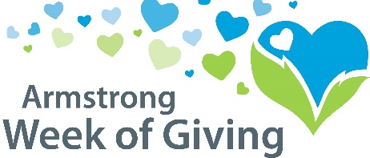 Partnered With 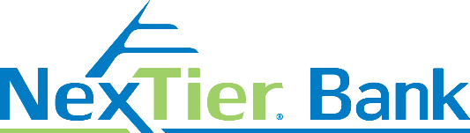

**Nonprofit Organization Checklist**

Send all required materials to the Community Foundation by April 21 to the information at the bottom, which includes:

**Required Registration Documents:**

1. Registration Form
2. Digital copy of organization logo (to [samantha@servingtheheart.org](mailto:samantha@servingtheheart.org))
3. Contribution of $250 to bonus fund – payable to “Week of Giving Match Fund”
4. **If** you are a **new** nonprofit participating please send a completed W-9 and your IRS determination letter

**Suggestions:**

* Inform the community about your participation in the Week of Giving
  + Discuss, educate, and send emails to Board Members and your donors
* Create a Publicity Plan
  + Add the Week of Giving prominently on your website homepage
  + Personalize emails and/or letters from your Board Members so that they can send to their contacts. This will give your Board Members a template so they can personalize your correspondence
  + Provide real life stories to promote your cause

**Action Items – After the Event:**

* Give thanks by sending emails, letters and on your social media pages
* Call and thank all companies and individuals who have given a large donation to your organization for the Week of Giving
* Send ALL donors a thank you letter, of note you are only required to send for donations over $250 but it is very important to thank ALL donors – The importance of a thank you cannot be overstated!