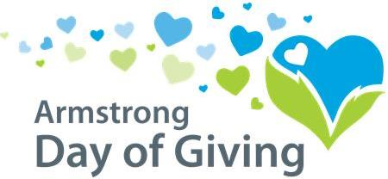

Nonprofit Organization Checklist

- Send all required materials to the Community Foundation by June 29th, which includes:
  - Current list of board of directors
  - Digital copy of organization logo (to tracy@servingtheheart.org)
  - Contribution of $250 to bonus fund

- Inform community about your participation in the Day of Giving
  - Discuss with Board Members
    - Educate them so they know all of the details to share with their friends and family and people in the community (don’t forget to strongly encourage them to donate themselves)
    - Contact your previous donors
    - Use the media kit to send emails, letters, etc. to get the word out about the Day of Giving.

- Create a Publicity Plan
  - Add the Day of Giving prominently on your website homepage
  - Make a schedule for sending your emails and posting to Facebook to keep the Day of Giving and your organization on the community radar but not so often that it is overwhelming for the recipients.
  - Personalize emails and/or letters from your Board members so that they can send to their contacts. This way it gives your Board members a template that they can personalize.
  - When promoting, use real life stories to promote your cause.
  - Be EXCITED about the Day of Giving and get your supporters EXCITED too!

- Thank yous
  - Send thank you by email, letter and on your social media pages
  - Call companies/individuals who have given a large donation to your organization for the Day of Giving
  - While only donations of $250+ are required to receive a letter, you should thank every single donor. The importance of a thank you cannot be overstated!

Armstrong County Community Foundation
220 S. Jefferson St. - Kittanning, PA 16201
724-548-5897
tracy@servingtheheart.org - jodi@servingtheheart.org
www.servingtheheart.org

