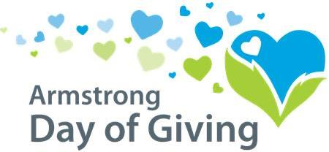

July 13th – 17th, 2020

Please help us raise more money by making a donation for the
Day of Giving, July 13th – 17th, 2020.

Two options for making your donation*
- Write a check payable to the participating organization you would like to support.
- Mail it to the participating organization OR
- Mail it to Day of Giving, PO Box 895, Kittanning, PA 16201.
Check must be dated anytime from July 13th through July 17th

- Make an Online Donation one of two ways.
  - The Community Foundation has set-up an online option for all of the participating nonprofit organizations located on our website www.servingtheheart.org.
-click on Day of Giving at the top of the homepage
-click on the Make a Donation tab
-complete the form and choose the nonprofit you would like to donate to…OR

  - You may contribute directly through the nonprofit organization’s online site.

Online Giving: Donations must be made between July 13th through July 17th.

* Please see complete rules & guidelines for eligible donations at www.servingtheheart.org

[Organization]
[Contact Name]
[Phone]
Insert Your Logo Here

Sponsored by:
