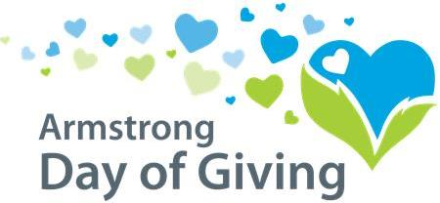

Sample - Introducing the Day of Giving
(send after “official” announcement has been made)

Dear ____,

Have you heard? During the week of July 13th – 17th, (your organization) will be participating in the 2020 Armstrong Day of Giving, raising money for nonprofits in our community! The Armstrong County Community Foundation will be once again sponsoring this event in partnership with NexTier Bank.

So, mark your calendars. We will be sending out more information closer to the date.

Of note, the Community Foundation is not a participant and will not be eligible for any of the Day of Giving donations or bonus funds. They host the Day of Giving simply to help area nonprofits like us! We get every penny of the money we bring in for our own organization, plus some bonus money on eligible donations!

We hope that you will help us make a difference by donating to us during the week of July 13th-17th, 2020!

Sincerely,

Sample - Reminder

Dear _____,

During the week of July 13th – 17th we (insert organization name) are/is participating in the 2020 Armstrong Day of Giving. We hope that you will consider a donation to us,

Donations made payable to (organization name) will be received in the following ways:
- Write a check payable to the participating organization you would like to support.
- Mail it to the participating organization OR
- Mail it to Day of Giving, PO Box 895, Kittanning, PA 16201.
Check must be dated anytime from July 13th through July 17th
- Make an Online Donation one of two ways.
  - The Community Foundation has set-up an online option for all of the participating nonprofit organizations located on our website www.servingtheheart.org.
-click on Day of Giving at the top of the homepage
-click on the Make a Donation tab
-complete the form and choose the nonprofit you would like to donate to…OR
  - You may contribute directly through the nonprofit organization’s online site.
Online Giving: Donations must be made between July 13th through July 17th.
We hope that you will help us make a difference!

Sincerely,

SAMPLE - EMAIL
(send Day of Event)

Dear _____,

Today is the big day! The 2020 Armstrong Day of Giving!

We hope that you will consider making a donation to (organization name). We appreciate your support and together we can make a difference!

Just as a reminder, donations made payable to (organization name) will be received in the following ways:

- Write a check payable to the participating organization you would like to support.
- Mail it to the participating organization OR
- Mail it to Day of Giving, PO Box 895, Kittanning, PA 16201.
Check must be dated anytime from July 13th through July 17th

- Make an Online Donation one of two ways.
  - The Community Foundation has set-up an online option for all of the participating nonprofit organizations located on our website www.servingtheheart.org.
-click on Day of Giving at the top of the homepage
-click on the Make a Donation tab
-complete the form and choose the nonprofit you would like to donate to…OR
  - You may contribute directly through the nonprofit organization’s online site.
Online Giving: Donations must be made between July 13th through July 17th.
Please contact us if you have any questions regarding the Day of Giving.

Sincerely,

