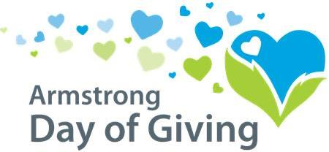
Name of organization:
Contact person:
Address:
Phone:
Email:
EIN number:
Website:
Facebook:
About Your Organization: (please limit to 1-3 sentences; this will go on our website with your logo) ____________________________________________________________________________________________________________________________________________________________________________________________________________________________________________________________________________________________________________________________________________________________________

By signing below, if we choose to participate in the Day of Giving, we:
- Acknowledge that we reviewed the PowerPoint presentation (either live or recorded)
- Acknowledge our receipt of guidelines for the event and agree to follow guidelines.
- Understand that noncompliance with these guidelines may result in forfeit of the bonus fund percentage that would have been allocated to our organization’s project.

Signature |  | Title
Print name |  | Date
Submit to the Community Foundation by February 20, 2019.

