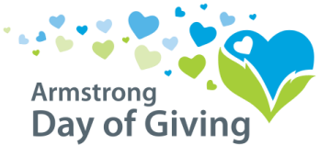
At a glance details:

- Minimum Gift*: $20.00
- Maximum Gift*: $5,000.00 per donor – per organization
  - Example: 1 donor can donate $5,000 to 4 different organizations
$20,000 would be matched.
- Organizations are prohibited from donating to themselves.
- Previous pledges, other regular gifts (like regular tithes or offerings), or proceeds from sales & fundraisers are ineligible for matching dollars. .
- *All gifts under $20 will be passed through

All qualifying donations must be dated from July 13th, 2020 through July 17th, 2020 and received in the Foundation office either by mail or from the participating nonprofit by Monday, July 20th, 2020.

The options to receive contributions are below:
- Write a check payable to the participating organization you would like to support.
- Mail it to the participating organization OR
- Mail it to Day of Giving, PO Box 895, Kittanning, PA 16201.
Check must be dated anytime from July 13th through July 17th

- Make an Online Donation one of two ways.
  - The Community Foundation has set-up an online option for all of the participating nonprofit organizations located on our website www.servingtheheart.org.
-click on Day of Giving at the top of the homepage
-click on the Make a Donation tab
-complete the form and choose the nonprofit you would like to donate
to…OR
  - You may set up your own form of online donation option. For example, PayPal, Go Fund Me, or through your online donation portal on your website.
If you choose to provide your own online option,
- Participating organizations are responsible to provide the Community Foundation a detailed receipt for all online donations received and
- Receipts must be submitted to the Community Foundation, 220 S. Jefferson St., Kittanning, PA 16201 by Monday, July 20th, 2020.
- Donations must be a minimum of $20 AFTER the processing fee is accessed.
Checks must be:
- Dated between July 13th and July 17th
- On-line donations must be posted between July 13th and July 17th, 2020

