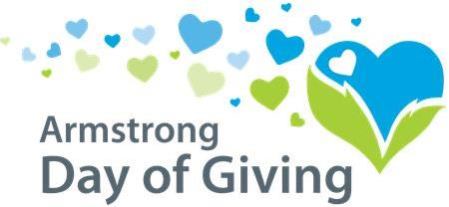
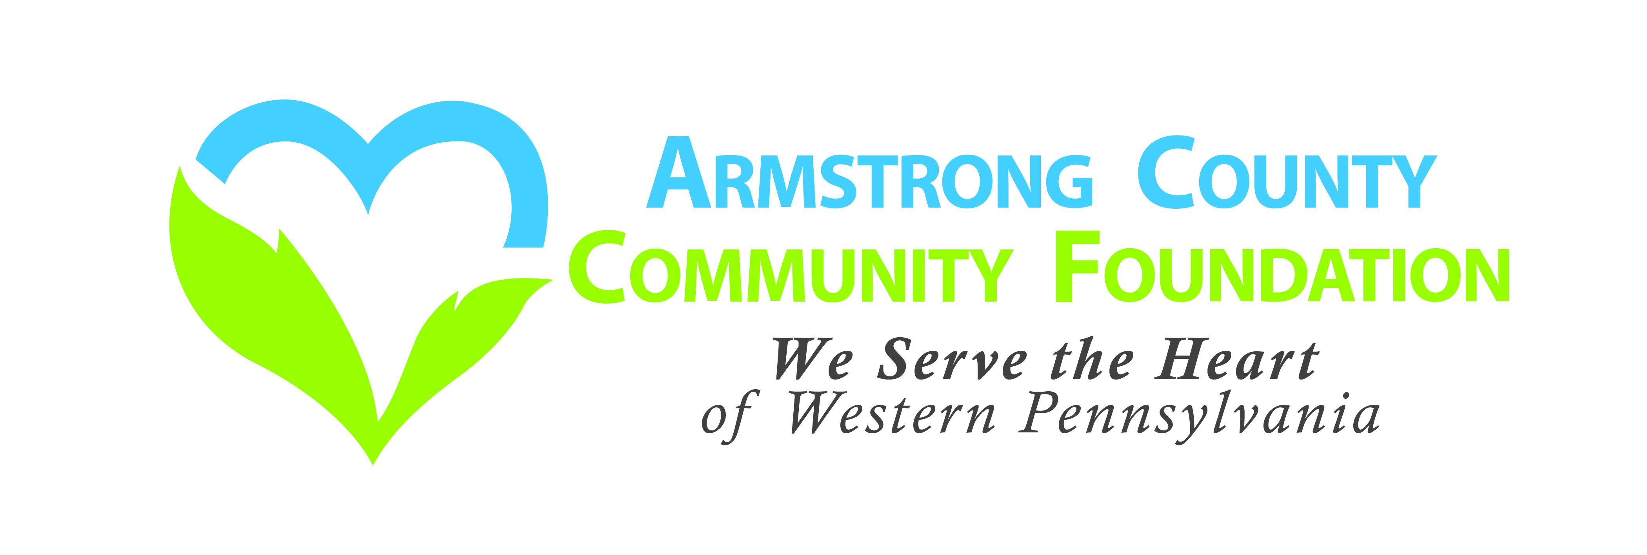

Thursday, May 14th, 2020
At NexTier Bank, Downtown Kittanning
All checks must be made payable to the
participating nonprofit organization.

(Donations will be accepted at participating nonprofits
during the week of May 11th through May 15th)

Donations may also be mailed to the
Day of Giving, PO Box 895, Kittanning, PA 16201
Must be dated between May 11th & May 15th

In partnership with:

