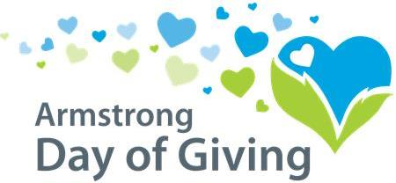

Thursday, May 14th, 2020

Please help us raise more money by making a donation on the
Day of Giving, Thursday, May 14, 2020.

Three options for making your donation*:
- ON May 14th, 2020 only - Hand deliver check to NexTier Bank, 222 Market St., Kittanning, PA 16201. NexTier will only accept checks dropped off on May 14th.
(Donations hand delivered after business hours on May 14th can be left in the mail slot.)
- Mail it to Day of Giving, PO Box 895, Kittanning, PA 16201.
    - Check must be dated anytime from May 11th through May 15th
- Online Giving: Donations must be made between May 11th and May 15th.

* Please see complete rules & guidelines for eligible donations at ww.servingtheheart.org

[Organization]
[Contact Name]
[Phone]
Insert Your Logo Here

