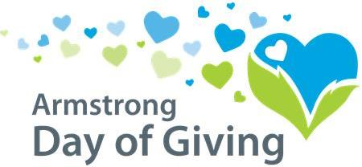
Your Letterhead

Dear Supporter [use first name if possible],

[Organization] is participating in the 8th annual Day of Giving, sponsored by the Community Foundation Serving the Heart of Western Pennsylvania in partnership with NexTier Bank and the Richard G. Snyder YMCA.
Any donation you make to us on the Day of Giving will be matched by their Match Fund, making YOUR donations go further! Please help us raise more money to _____ by making a donation on the Day of Giving, Thursday, May 10, 2018.
Three options for making your donation*:
1. Write a check to [organization name] and hand deliver it on May 10, 2018 to NexTier Bank, 222 Market St., Kittanning, PA 16201.
2. Write a check to [organization] and mail it to Day of Giving, PO Box 895, Kittanning, PA 16201 on May 10, 2018 (postmark must be May 10, 2018, not delivered on May 10).
3. Make an online donation on our website [web address] on May 10, 2018.
* Please see complete rules & guidelines for eligible donations at www.servingtheheart.org

Thank you for your continued support, and don’t forget to mark your calendar for the Day of Giving, May 10, 2018!

Sincerely,

[Organization representative]

