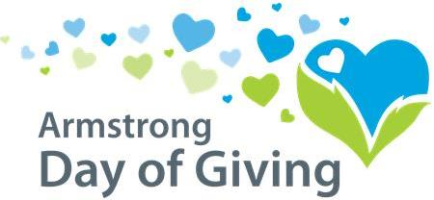
Your nonprofit letterhead

Dear Supporter [use first name if possible],

[Organization] is participating in the 9th annual Day of Giving, sponsored by the Armstrong County Community Foundation in partnership with NexTier Bank and the Richard G. Snyder YMCA.
Any eligible donation you make to us on the Day of Giving will help us further our mission of ____ and will get a portion of the bonus fund! Please help us raise more money to _____ by making a donation on the Day of Giving, Thursday, May 9, 2019.
Three options for making your donation*:
1. Write a check to [organization name] and hand deliver it on May 9, 2019 to NexTier Bank, 222 Market St., Kittanning, PA 16201.
2. Write a check to [organization] and mail it to Day of Giving, PO Box 895, Kittanning, PA 16201- the postmark must be May 9, 2019, not delivered on May 9).
3. Make an online donation on our website [web address] on May 9, 2019.
* Please see complete rules & guidelines for eligible donations at www.servingtheheart.org

Thank you for your continued support, and don’t forget to mark your calendar for the Day of Giving, May 9, 2019!

Sincerely,

[Organization representative]

