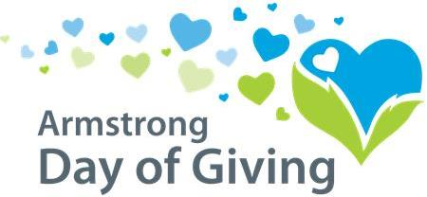
Day of Giving Guidelines
1. Nonprofit organizations [501(c) 3] wishing to participate in the Day of Giving must attend the Nonprofit Training on Thursday, January 25th at 10 am or Tuesday, January 30th at 5:00 pm. Both trainings will be held at NexTier Bank, 222 Market Street, Kittanning.
2. Nonprofit organizations [501(c) 3] (including schools, churches & municipalities) in or serving Armstrong County (other foundations and religiously affiliated organizations are not eligible to participate, unless they are raising money for a special project that serves the larger community. Based on the submitted information, the Community Foundation will determine if the organization is eligible.) must submit the following to the Community Foundation by April 16th to be eligible.
- A signed participation agreement
- IRS determination letter
- Current list of board of directors
- Digital copy of organization logo
3. Participating organizations will be required to have a contribution of $250+ made to the match fund on their behalf. This money can be raised from a single donor, multiple donors, or given by the organization itself. All checks designated to the match fund need to be made out to “Day of Giving Match Fund” with “your organization” in the memo and mailed to Day of Giving Match Fund, PO Box 895, Kittanning, PA 16201.
4. Each approved organization is eligible to receive funds with no maximum limit for the organization; HOWEVER, only gifts of $20 (minimum) to $5,000 will be matched. Donations must be a minimum of $20 to be matched. Organizations are prohibited from donating to themselves (i.e. organizations cannot bring the proceeds from a fundraiser for matching funds). Previous pledges, other regular gifts, proceeds from sales or fundraisers, or grants are ineligible for matching dollars. Organizations that do not abide by these guidelines will be disqualified from receiving any match dollars.
5. All donations for approved Day of Giving participants must be made payable to the organization the donor is supporting to qualify for matching funds.
6. Every approved organization that receives qualifying contributions during the Day of Giving will receive a portion of the match. The matching dollars will be pro-rated, and will depend upon the total amount of the match fund, and the total amount of donations received.
6. All qualifying donations must be received on or postmarked on May 10, 2018. Online and check donations will be accepted. Online donation will be processed through each individual organization. A detailed receipt of online donations is required to be provided to the Community Foundation the day after the Day of Giving. Donations hand delivered after business hours can be left in the mail slot.
7. The Community Foundation is not eligible to participate or to receive matching funds.
Community Foundation
220 S. Jefferson St. - Kittanning, PA 16201
724-548-5897
tracy@servingtheheart.org - jodi@servingtheheart.org
www.servingtheheart.org

