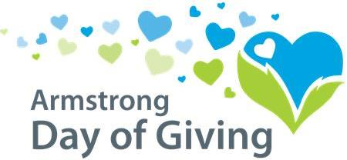

Suggested Communication Timeline for Nonprofit Organizations
- As soon as event is announced
  - Send a note to donors letting them know about the opportunity to give and make their money go further with specific details about the Day of Giving
  - Add basic Day of Giving information to your website homepage
  - Include information on the Day of Giving in all your communications going to donors, volunteers and staff
  - Start considering potential donors who might supply the $250 match contribution on behalf of your organization
- 1 month out
  - Start communicating through social media
  - Encourage staff to include the basic Day of Giving info in their email tagline
  - Send a special e-blast reminder to volunteers, donors and staff with details about the event
  - Plan a special public or donor-focused event (such as a kick-off or open house) to generate excitement for the Day of Giving
- 2 weeks out
  - Send out emails, postcards, letters, etc. to create awareness and excitement about the Day of Giving. Be sure to include event day details.
  - Post stories of your organizations’ impact on social media and encourage people to support you on the Day of Giving(be sure to include detailed info on how to donate)
  - Post at least one social media update daily-even if it’s just sharing other posts
  - Send out a calendar invite for the Day of Giving to all of your donors as a “save the date” reminder to support your organization on that day
  - Encourage your donors, volunteers and staff to promote your organization through their own social media pages
- 1 week out
  - Encourage your staff and board to reach out to their family, friends and donors they are closest to for a personal ask
  - Continue posting stories of your cause and event day information on your website and social media
  - Be sure the donation page on your website is prominent and easily accessible (and in working order) if your organization is choosing to accept online donations
- Two days before
  - Send a reminder email to your supporters with a specific call to action-be sure to include the detailed information on how they can support your organization through a donation on the Day of Giving
  - Post 2-3 updates daily on social media
  - Make personal asks and calls to donors-be sure to give them detailed information on how they can support your organization through a donation on the Day of Giving
- Day of Giving
  - Post regular updates to social media to keep your supporters informed and engaged throughout the event. The Community Foundation will be doing this too!
  - Create exciting posts about your progress and encourage people to give
  - Thank donors through social media to drive excitement and encourage more people to give
- After the final results are in
  - Send out thank you letters to your donors and to match partners
  - Call your major donors to thank them
  - Post the final results on social media and on your website

Community Foundation
220 S. Jefferson St. - Kittanning, PA 16201
724-548-5897
tracy@servingtheheart.org - jodi@servingtheheart.org
www.servingtheheart.org

